Creating Jobs by Simplifying Agency Rules
Red tape is strangling Oregon businesses and killing jobs. Many state lawyers see their role as winning—at any cost—by defending agency overreach. I will confine agencies to their proper roles under the law, helping to make investing in Oregon business and hiring employees safe again. Electing another lifelong government employee as Attorney General would just make things worse.
Restoring Accountability and the Rule of Law
It is long past time to hold Oregon’s agencies and public officials accountable under the law. Oregon deserves statewide leaders who will dare to take action against agency and official misconduct, and against powerful financial institutions destroying our futures. I will do that. My opponent, however, has proven her willingness to bend the law to protect officials from the People. Oregon also deserves an Attorney General with sensible views on the criminal justice system. I will not stretch the law to invent new rights for criminals—like my opponent.
Fighting for Local Control and Decentralization
We can no longer afford multiple layers of government in charge of the same thing. Excessive federal powers are crippling Oregon’s future by borrowing us into financial oblivion, burning down Oregon’s forests, locking away natural resources, and even micromanaging Portland’s water supply. As Attorney General, I will fight excessive federal power with every tool available, and help set Oregon free to determine its own future.
www.buchal.com
Paid for by Buchal for Attorney General
3425 SE Yamhill Street, Suite 100
Portland, OR 97214

Phone: 503-227-1011
Fax: 503-573-1939
E-mail: buchaljames@gmail.com

BUCHAL FOR ATTORNEY GENERAL
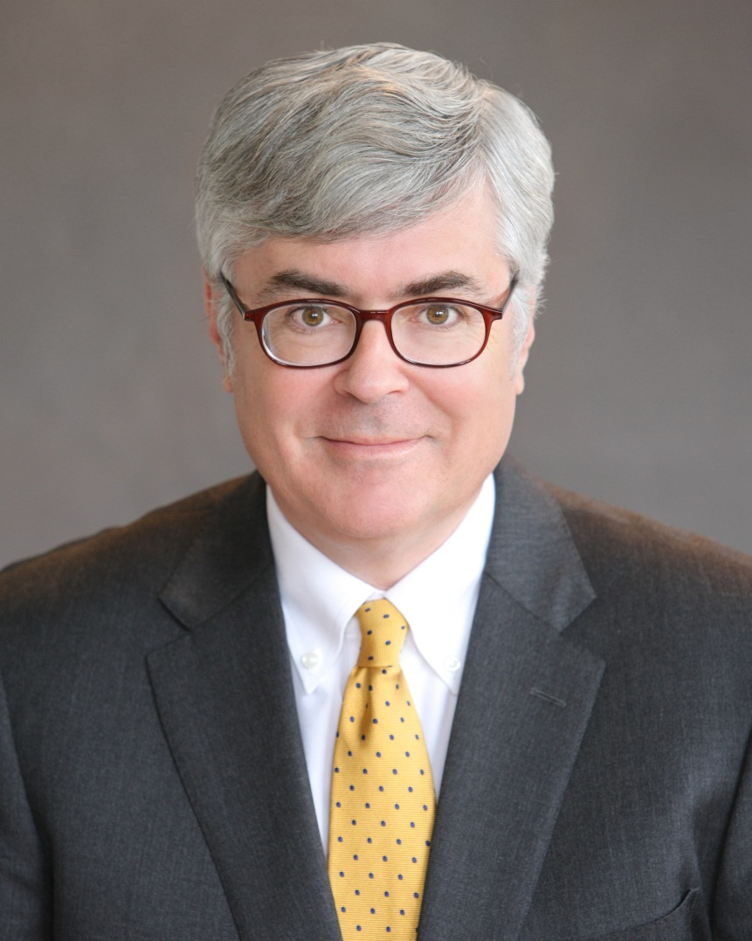
- Graduated from Harvard College (1981, physics)
- Graduated from Yale Law School (1985)
- Graduated from Yale Business School (1985)
- Highest “AV” Rating as a Private Attorney
- Expert in Administrative Law and Government Legal Issues
- Not a Puppet of State Employee Unions and Teacher’s Unions
- Not a Puppet of Large Corporations
- Endorsed by Oregonians in Action PAC, Oregon Family Farm Association PAC and many others
“As Oregon Attorney General, my priority will not be to win cases for bureaucrats, but to do justice for the People.”

